- Task1 Download & install Zenmap from official website on your Windows PC
- Task2 Find your local IP address & your LAN subnet
- Task3 Find the list of live hosts/PC’s in your IP subnet
- Task4 How many hosts are live in your subnet?
- Task5 What are the IP addresses of the live hosts?
- Task6 What are the MAC addresses of the live hosts?
- Task7 Display & save the output topology in PDF Format on your desktop

- Task2 Find your local IP address & your LAN subnet
IPv4 Address. . . . . . . . . . . : 10.0.0.5
Subnet Mask . . . . . . . . . . . : 255.255.255.0

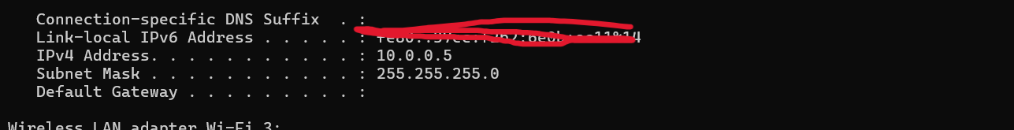

- Task3 Find the list of live hosts/PC’s in your IP subnet

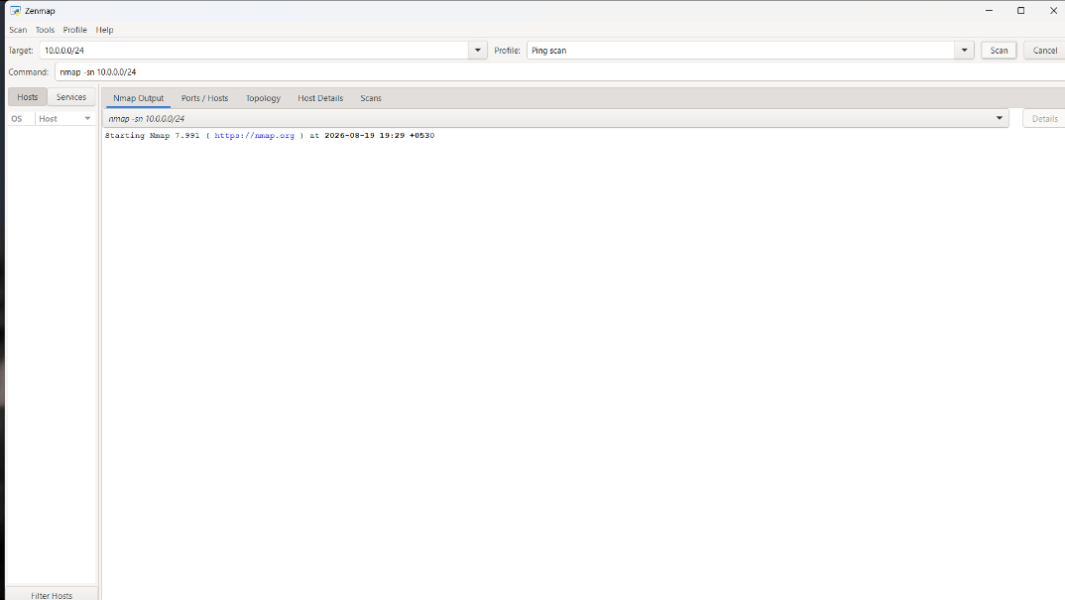
- Task4 How many hosts are live in your subnet?
1 host are live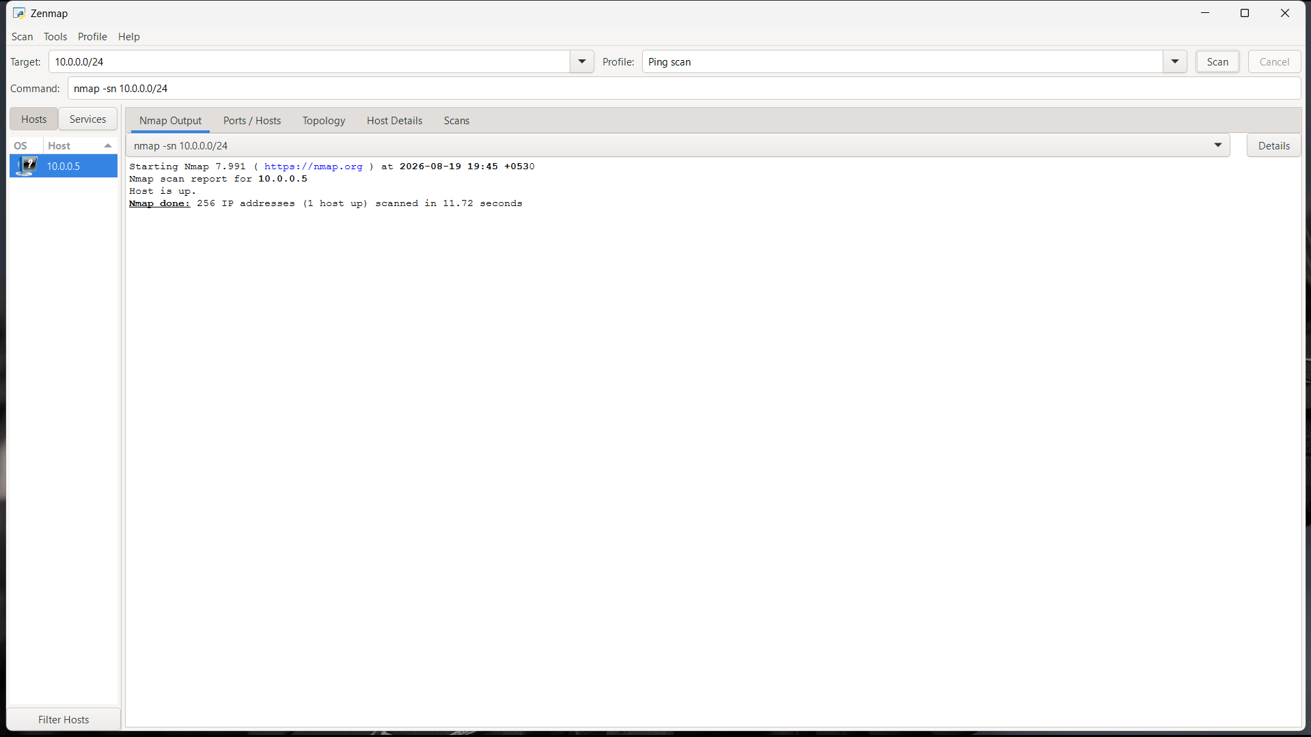

- Task5 What are the IP addresses of the live hosts?
The only IP address of the live host is 10.0.0.5

- Task7 Display & save the output topology in PDF Format on your desktop
